**COMPUTER NETWORKS LAB WEEK #1**

Name: Laxmikant Bhujang Gurav

SRN: PES1UG20CS658

Roll no : 55

Section : K

**#** ***Installing necessary utilities***

sudo apt-get install ***name_of_the_tool***

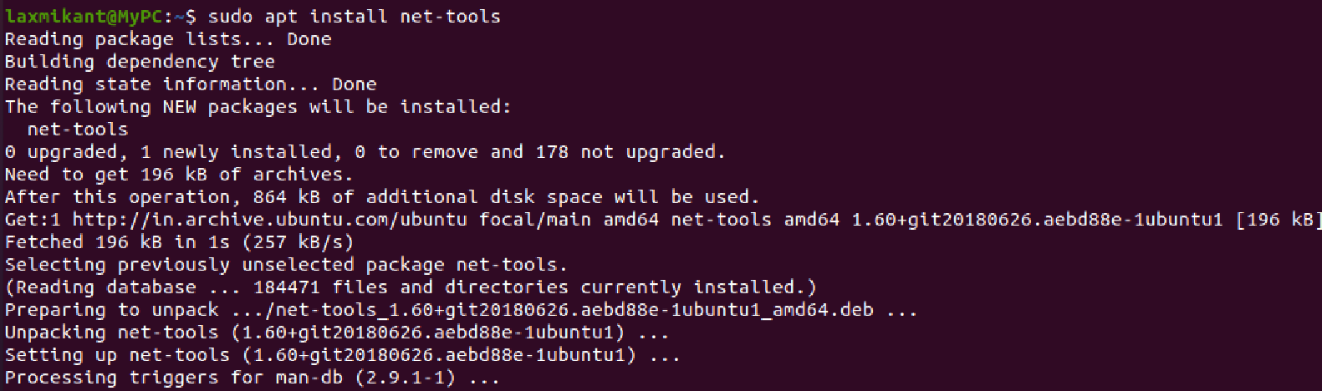

**Task 1: Linux Interface Configuration (ifconfig / IP command)**

**Step 1:** To display status of all active network interfaces.

**ifconfig** (or) **ip addr show**

Analyze and fill the following table:

**ip address table:**

|  |  |  |
| --- | --- | --- |
| **Interface name** | **IP address (IPv4 / IPv6)** | **MAC address** |
| enp0s3 | IPv4: 10.0.2.15  IPv6: fe80::e1d4:bcb3:7fd5:10e6 | 08:00:27:cb:5a:f6 |
| lo | IPv4: 127.0.0.1  IPv6: ::1 | 00:00:00:00:00:00 |

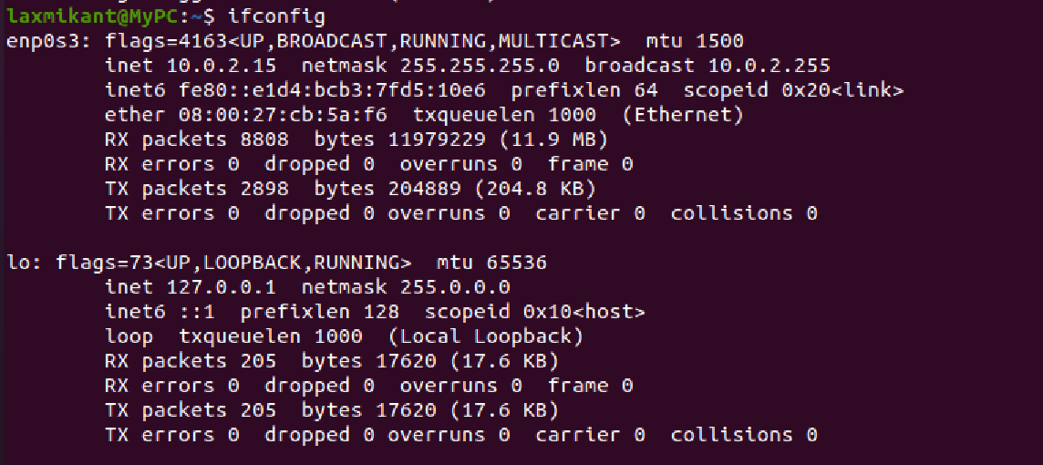

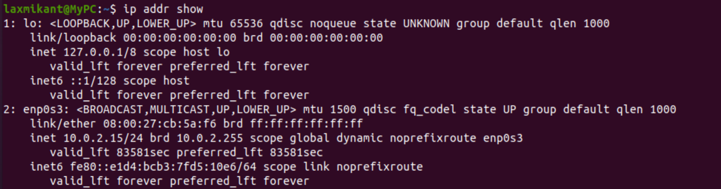

**Step 2:** To assign an IP address to an interface, use the following command. **sudo ifconfig interface_name 10.0.your_section.your_sno netmask 255.255.255.0** (or) **sudo ip addr add 10.0.your_section.your_sno /24 dev interface_name**

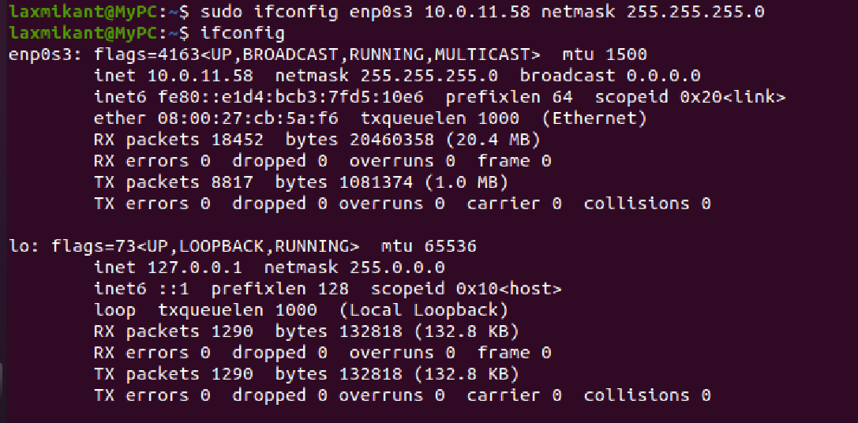

**Step 3:** To activate / deactivate a network interface, type.

**sudo ifconfig interface_name down**

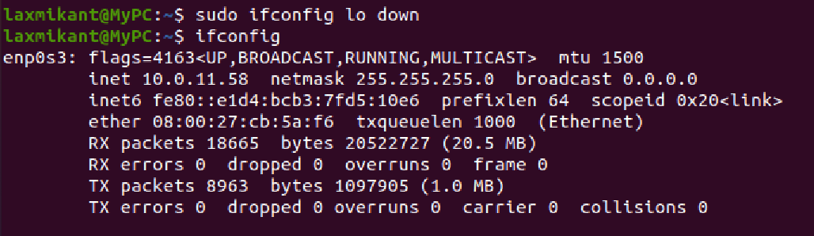

**sudo ifconfig interface_name up**

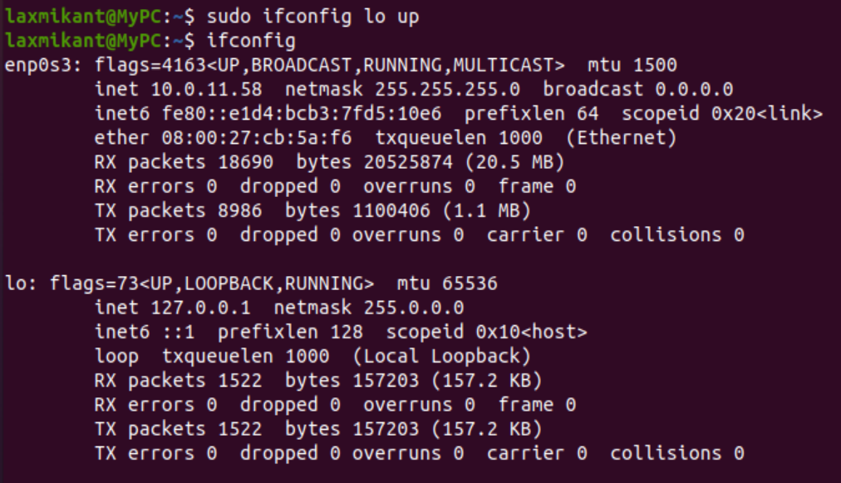

**Step 4:** To show the current neighbor table in kernel, type

**ip neigh**

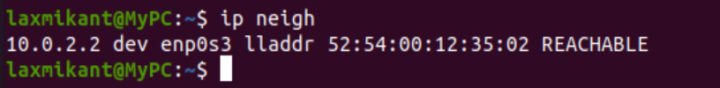

# Task 2: Ping PDU (Packet Data Units or Packets) Capture

**Step 1:** Assign an IP address to the system (Host).

Note: IP address of your system should be 10.0.your_section.your_sno.

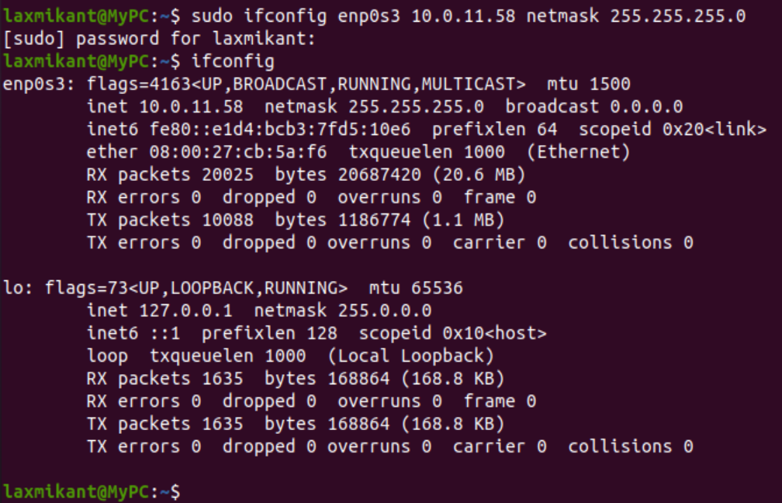

**Step 2:** Launch Wireshark and select ‘any’ interface

**Step 3:** In terminal, type **ping 10.0.your_section.your_sno**

## Observations to be made

**Step 4:** Analyze the following in Terminal

* TTL
* Protocol used by ping
* Time

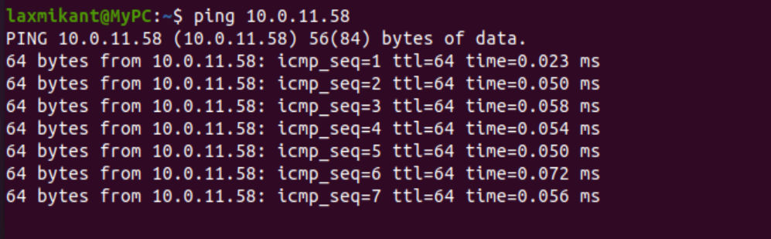

**Step 5:** Analyze the following in Wireshark

On Packet List Pane, select the first echo packet on the list. On Packet Details ™Pane, click on each of the four “+” to expand the information. Analyze the frames with the first echo request and echo reply and complete the table below.

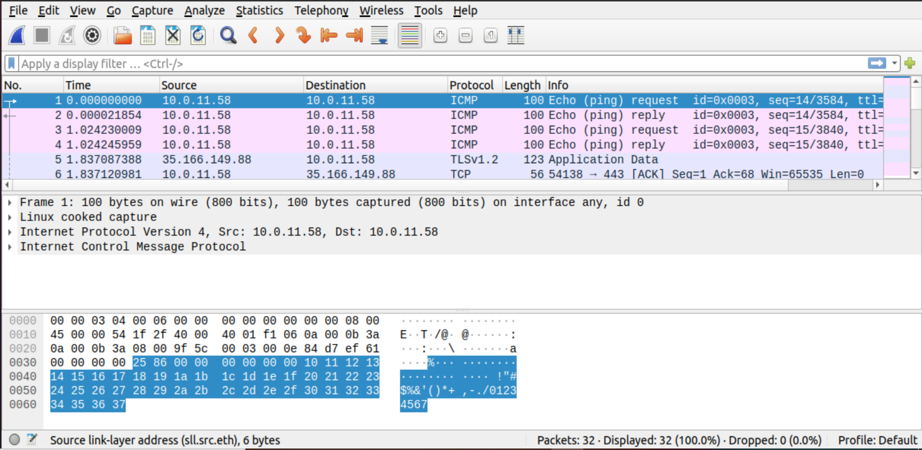

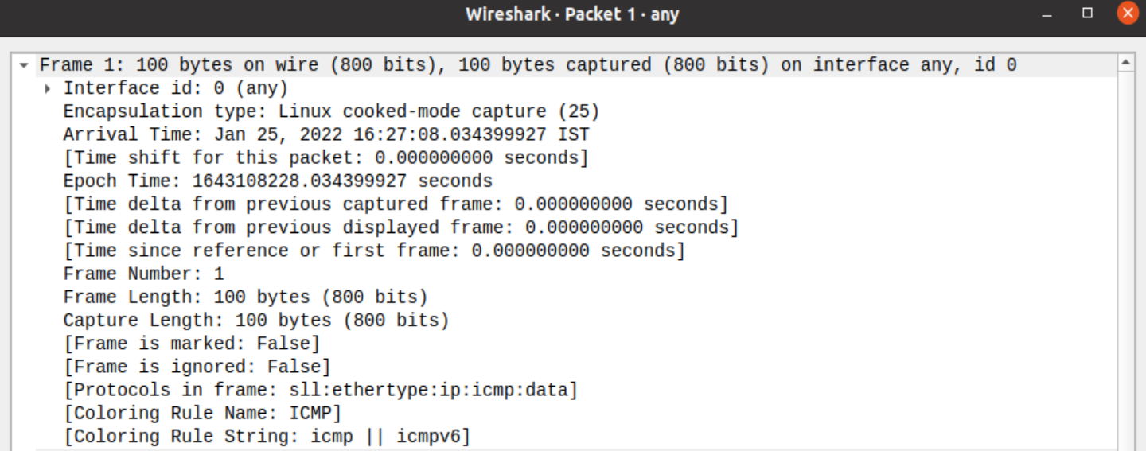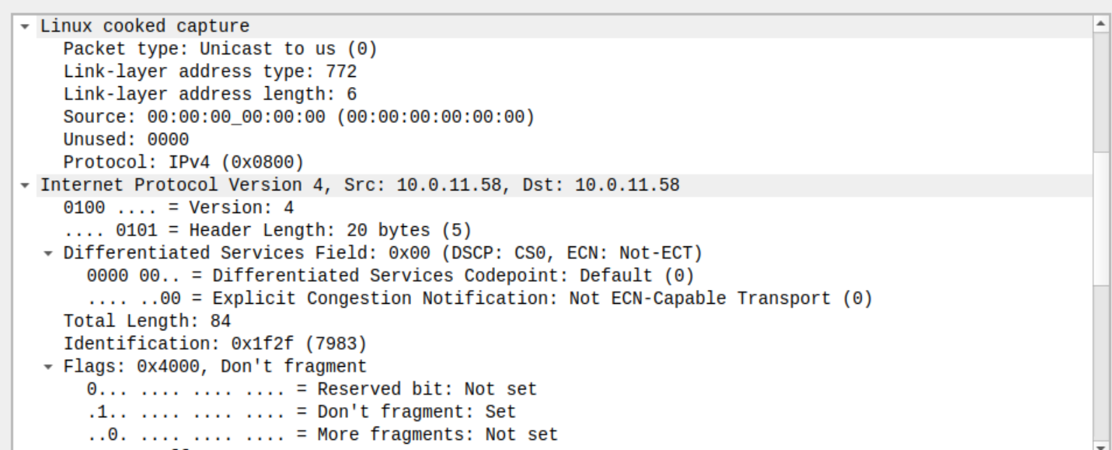

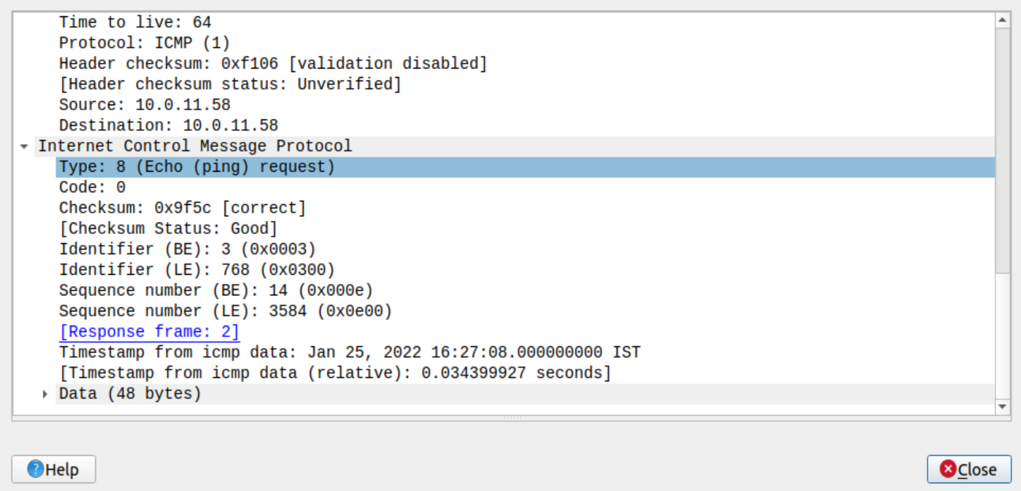

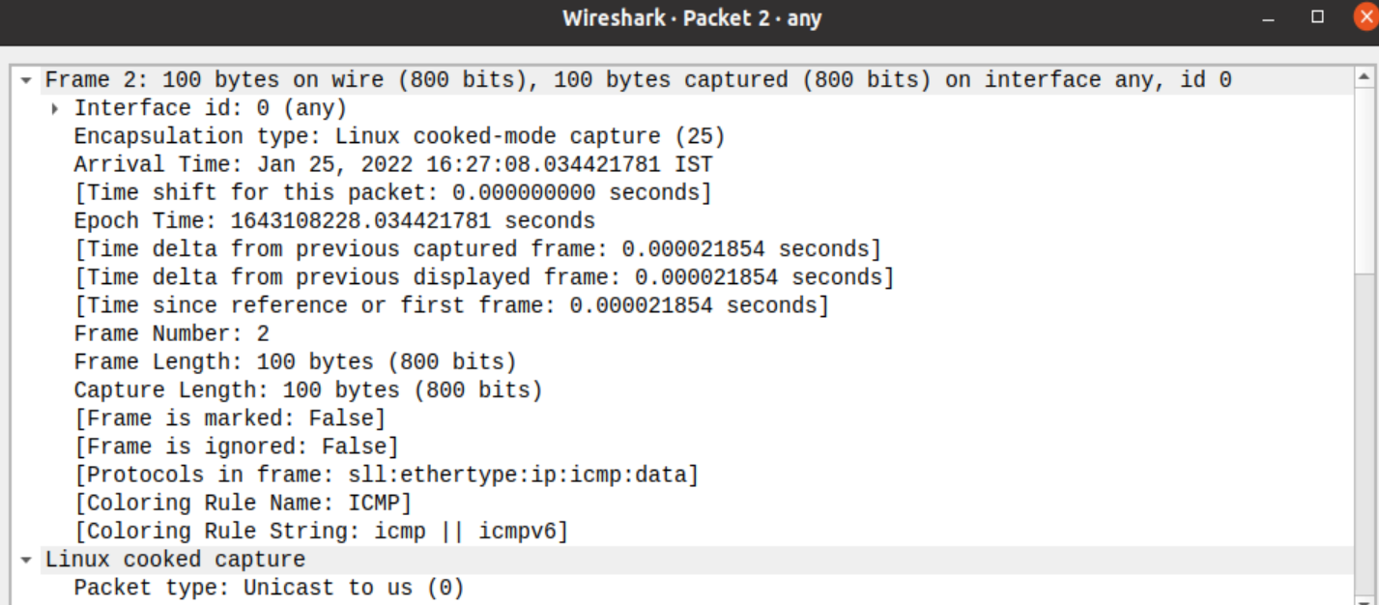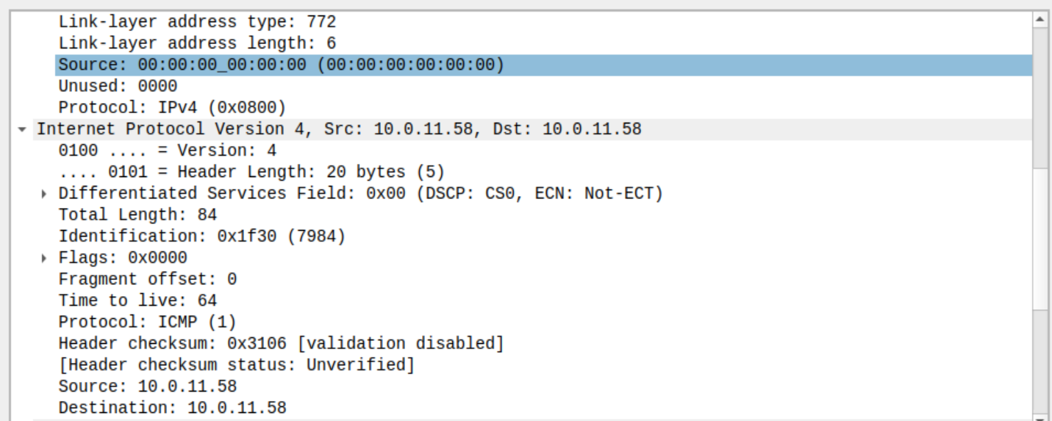

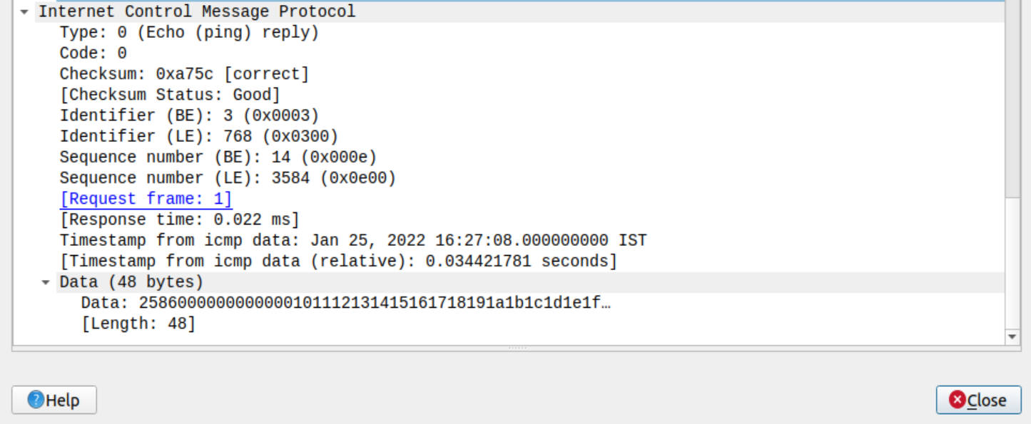

|  |  |  |
| --- | --- | --- |
| **Details** | **First Echo Request** | **First Echo Reply** |
| Frame Number | 1 | 2 |
| Source IP address | 10.0.11.58 | 10.0.11.58 |
| Destination IP address | 10.0.11.58 | 10.0.11.58 |
| ICMP Type Value | 8 | 0 |
| ICMP Code Value | 0 | 0 |
| Source Ethernet Address | 00.00.00.00.00.00 | 00.00.00.00.00.00 |
| Destination Ethernet Address | 00.00.00.00.00.00 | 00.00.00.00.00.00 |
| Internet Protocol Version | 4 | 4 |
| Time To Live (TTL) Value | 64 | 64 |

# Task 3: HTTP PDU Capture

**Using Wireshark’s Filter feature**

**Step 1:** Launch Wireshark and select ‘any’ interface. On the Filter toolbar, type-in ‘http’ and press enter

**Step 2:** Open Firefox browser, and browse [www.flipkart.com](http://www.flipkart.com/)

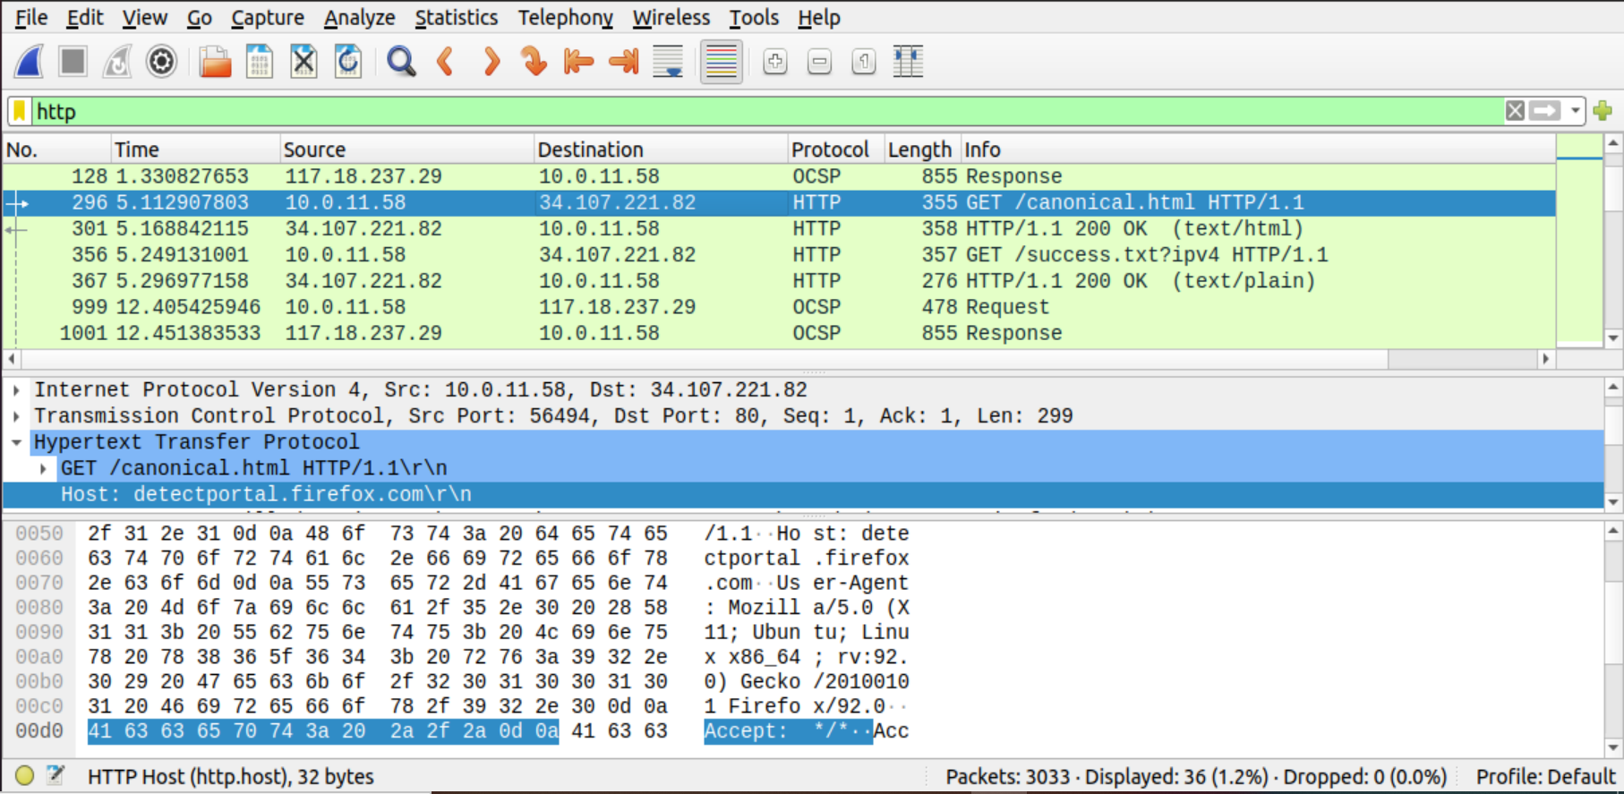

## Observations to be made

**Step 3:** Analyze the first (interaction of host to the web server) and second frame (response of server to the client). By analyzing the filtered frames, complete the table below:

|  |  |  |
| --- | --- | --- |
| **Details** | **First Echo Request** | **First Echo Reply** |
| Frame Number | 296 | 301 |
| Source Port | 56494 | 80 |
| Destination Port | 80 | 56494 |
| Source IP address | 10.0.11.58 | 34.107.221.82 |
| Destination IP address | 34.107.221.82 | 10.0.11.58 |
| Source Ethernet Address | 08.00.27.cb.5a.f6 | 52.54.00.12.35.02 |
| Destination Ethernet Address | 52.54.00.12.35.02 | 08.00.27.cb.5a.f6 |

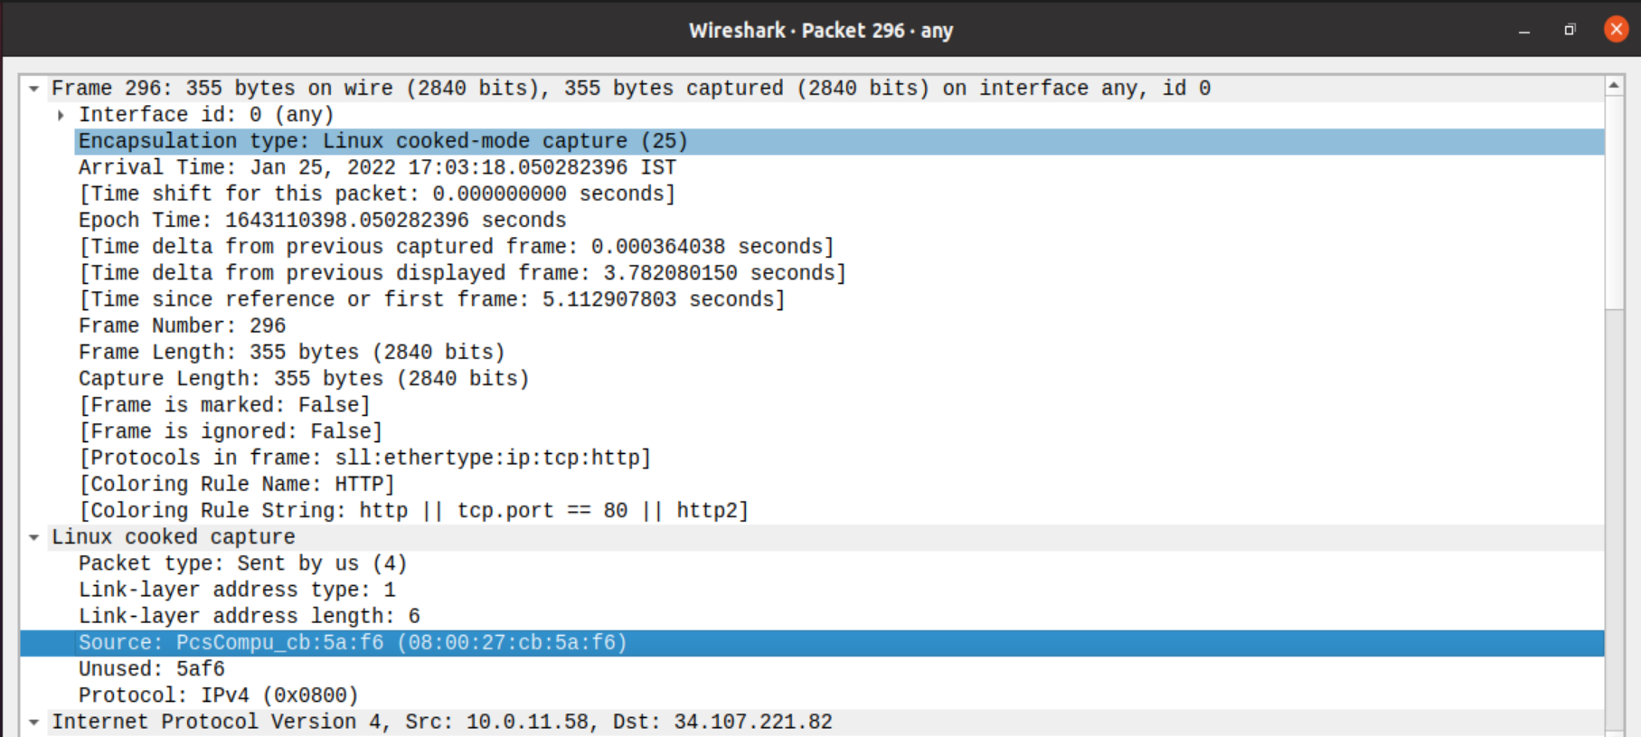

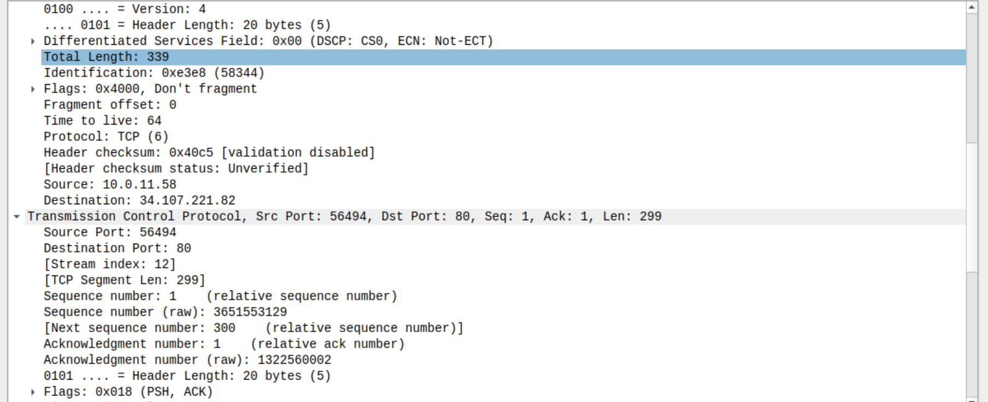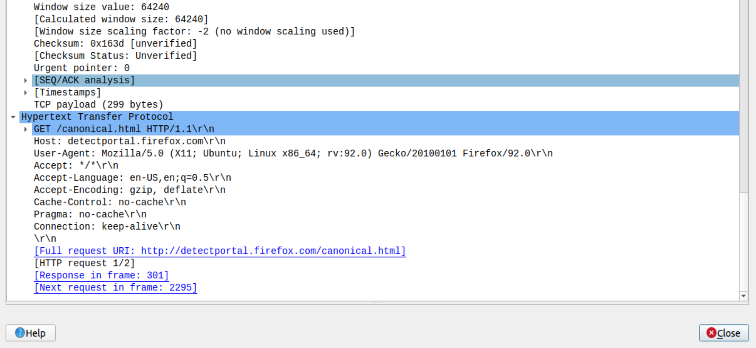

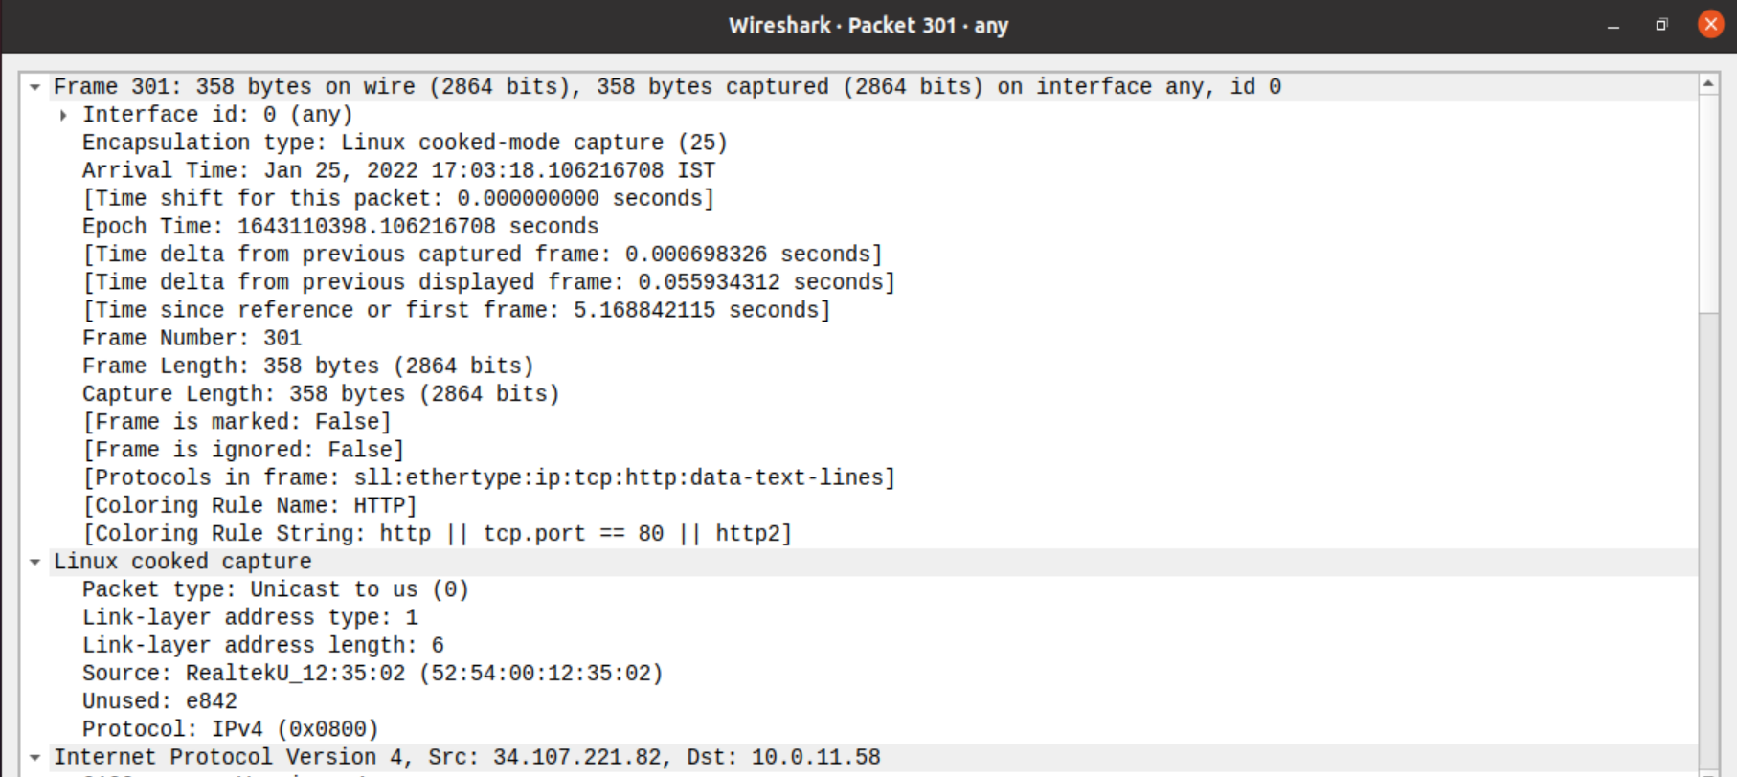

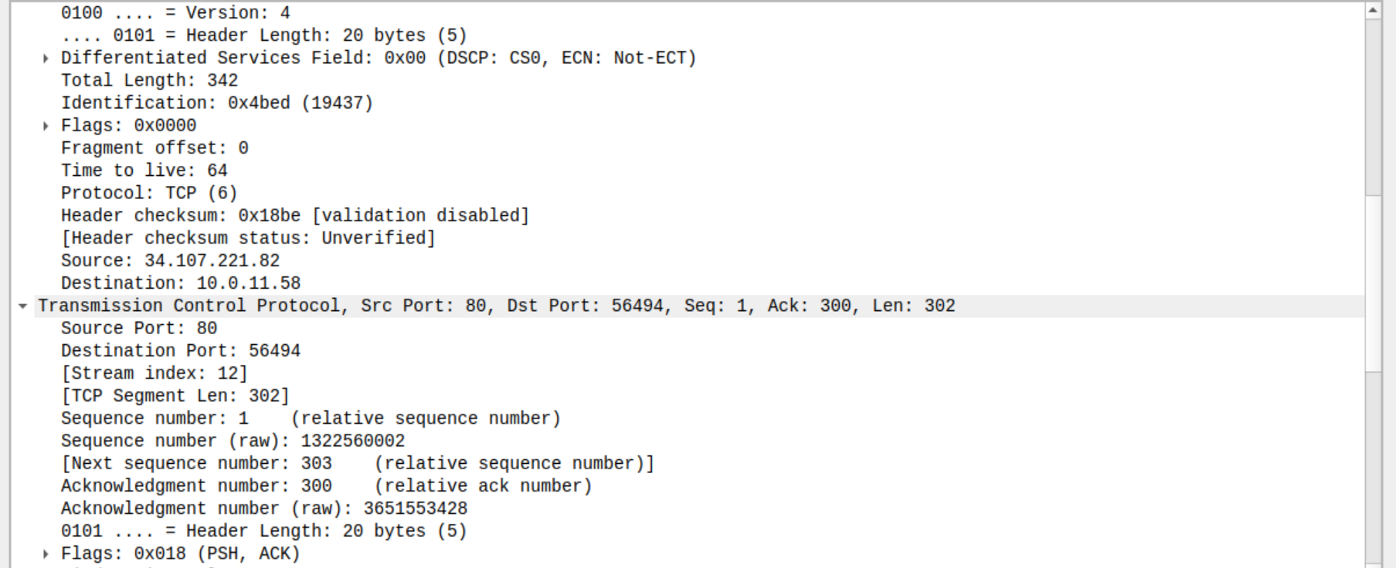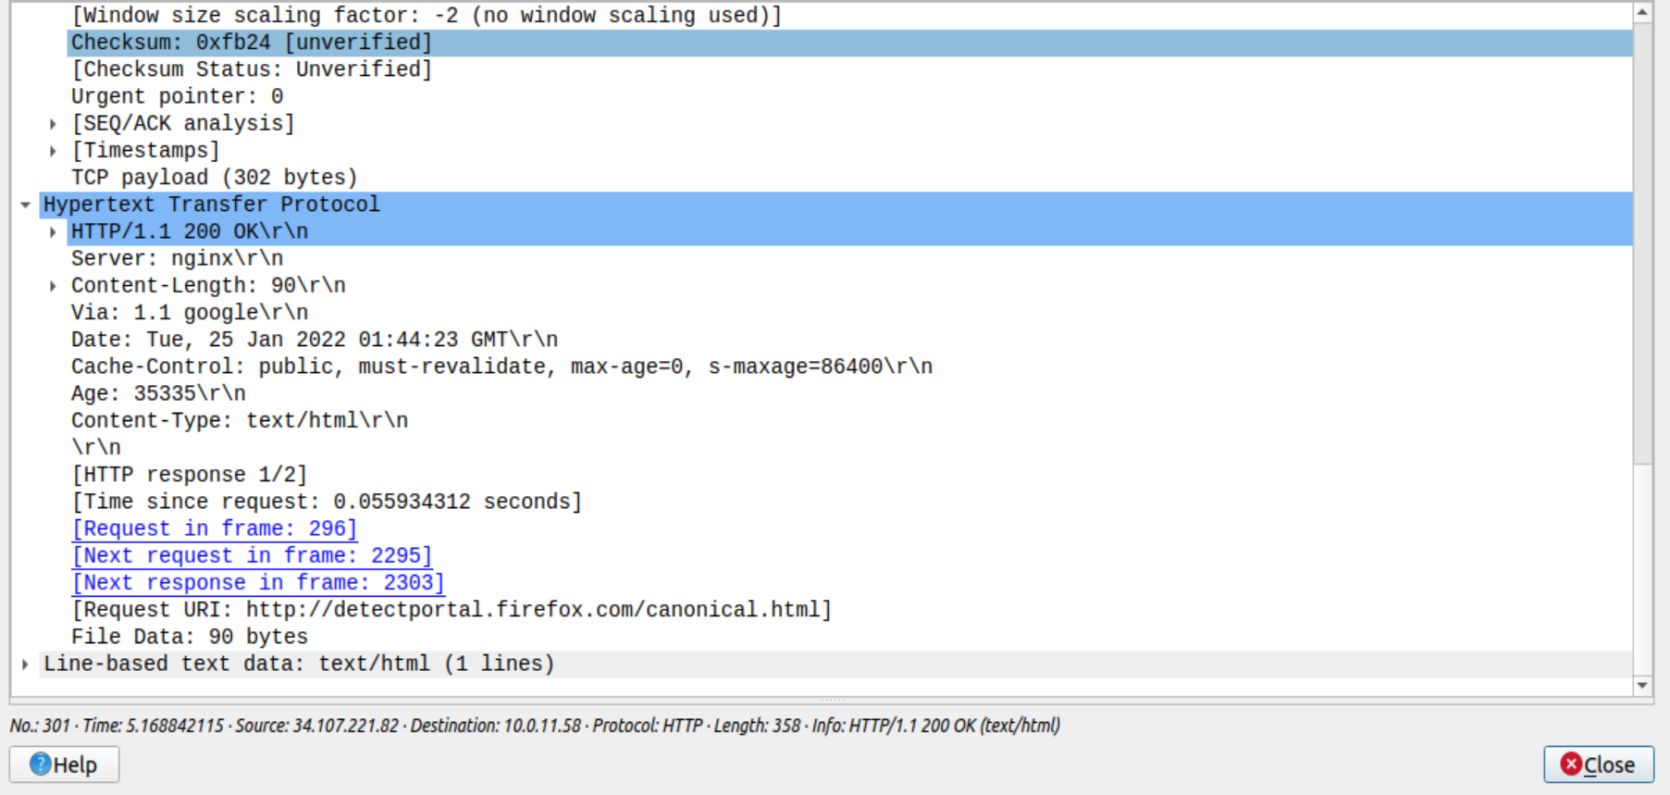

**Step 4:** Analyze the HTTP request and response and complete the table below.

|  |  |  |  |
| --- | --- | --- | --- |
| **HTTP Request** |  | **HTTP Response** |  |
| Get | /canonical.html HTTP/1.1 | Server | nginx |
| Host | detectportal.firefox.com | Content-Type | Text/html |
| User-Agent | Mozilla/5.0 (X11; Ubuntu; Linux x86_64; rv:92.0) Gecko 20100101 Firefox/92.0 | Date | Tue, 25 Jan 2022 01:44:23 GMT |
| Accept-Language | en-US, en ; q=0.5 | Location | https://www.flipkart.com/ |
| Accept-Encoding | gzip , deflate | Content-Length | 90 |
| Connection | Keep-alive | Connection | keep-alive |

**Using Wireshark’s Follow TCP Stream**

**Step 1:** Make sure the filter is blank. Right-click any packet inside the Packet List Pane, then select ‘Follow TCP Stream’. For demo purpose, a packet containing the HTTP GET request

“GET / HTTP / 1.1” can be selected.

Step 2: Upon following a TCP stream, screenshot the whole window.

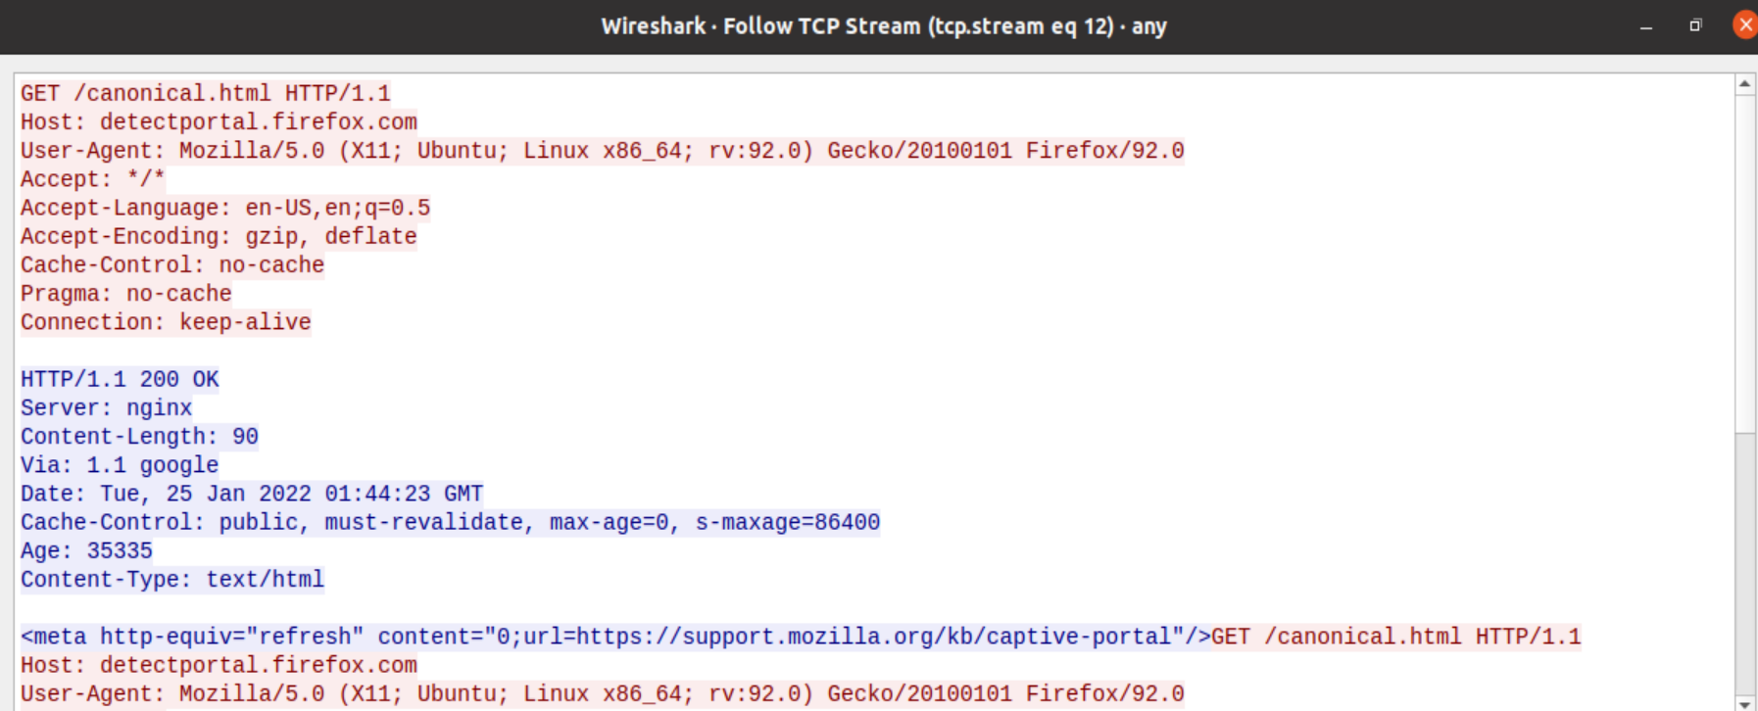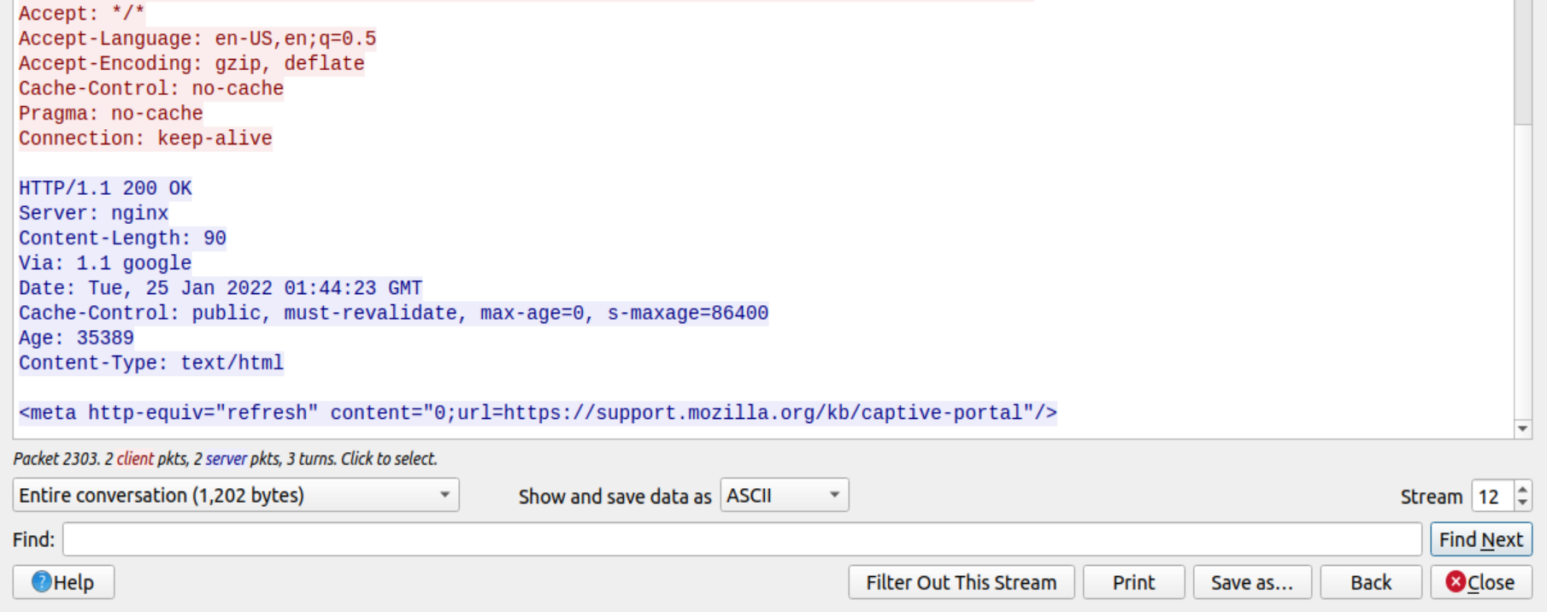

# Task 4: Capturing packets with tcpdump

**Step 1:** Use the command **tcpdump -D** to see which interfaces are available for capture.

**sudo tcpdump -D**

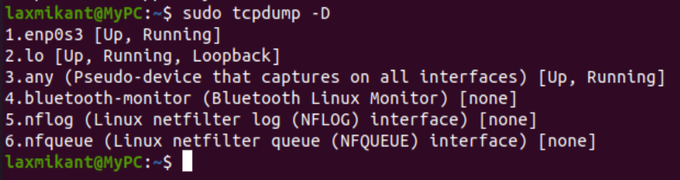

**Step 2:** Capture all packets in any interface by running this command:

## sudo tcpdump -i any

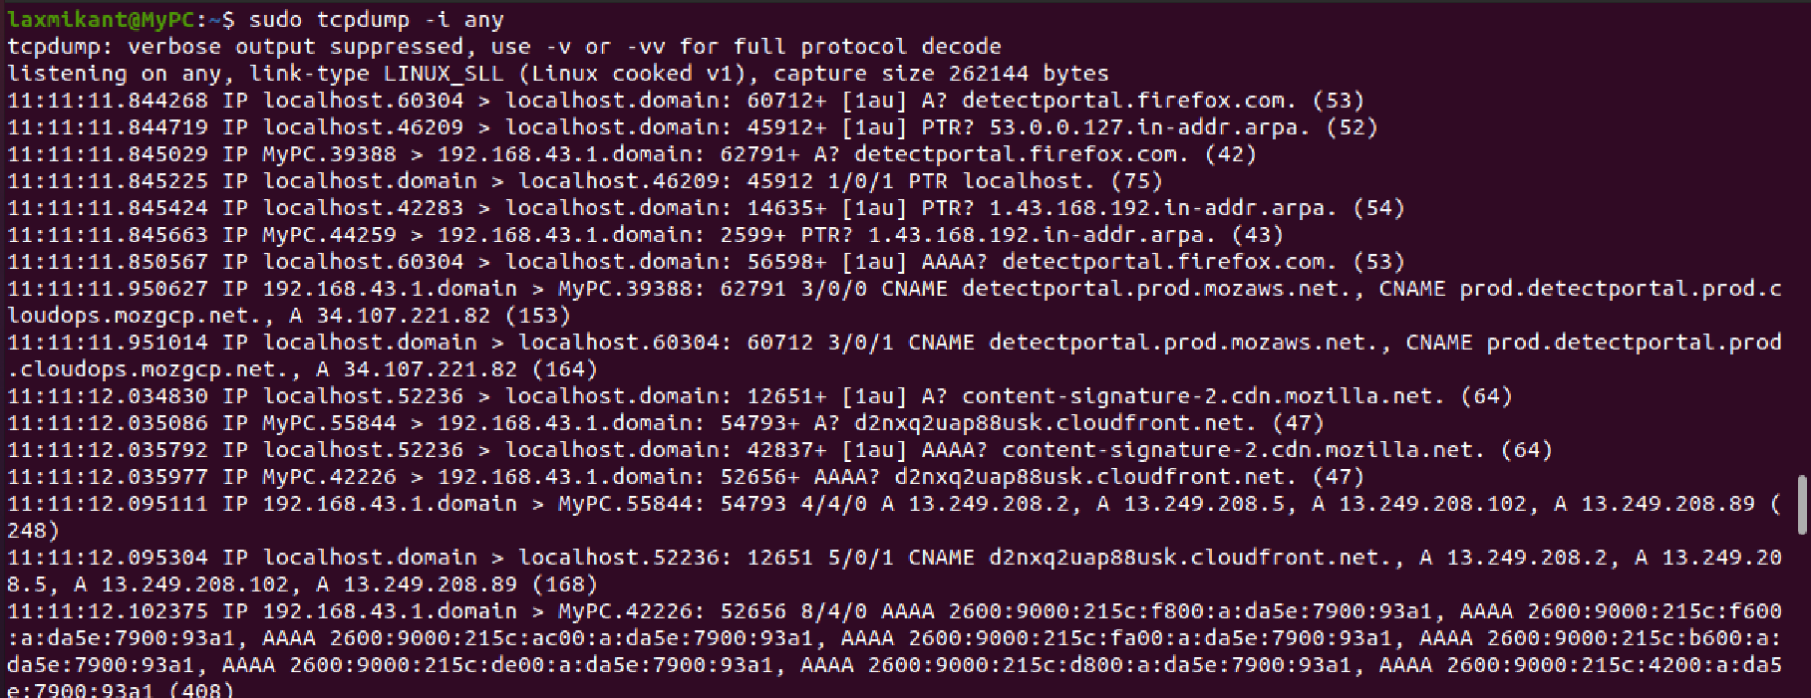

Note: Perform some pinging operation while giving above command. Also type [www.google.com](http://www.google.com/) in browser.

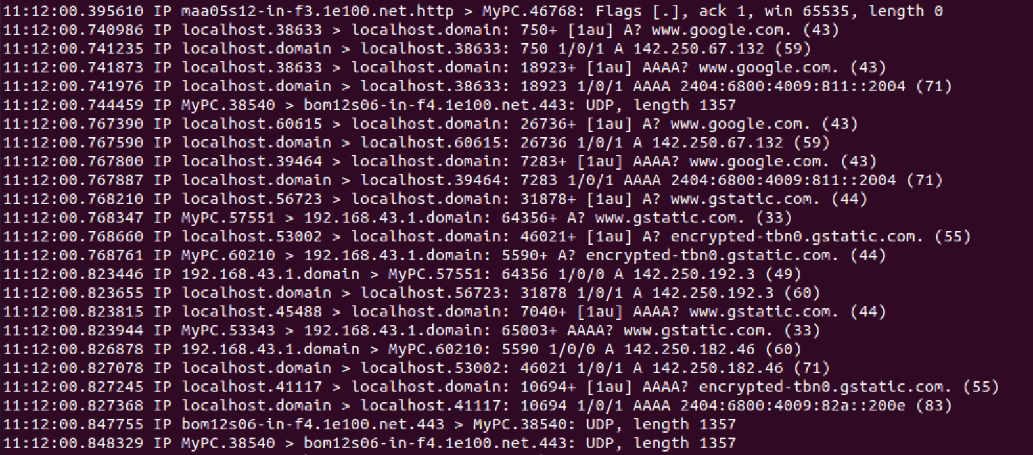

**After typing** [**www.pes.edu**](http://www.pes.edu) **in browser.**

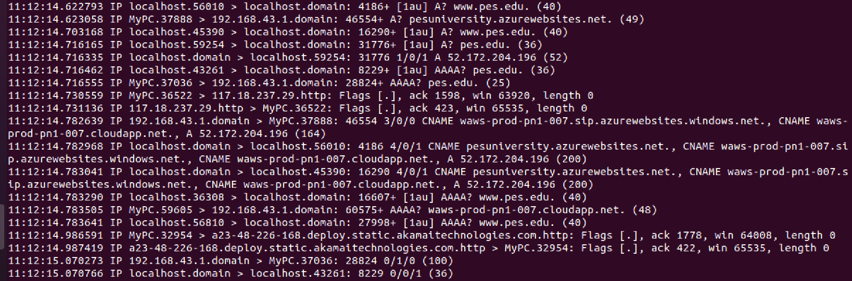

## Observation

**Step 3:** Understand the output format.

**Step 4:** To filter packets based on protocol, specifying the protocol in the command line. For example, capture ICMP packets only by using this command:

## sudo tcpdump -i any -c5 icmp

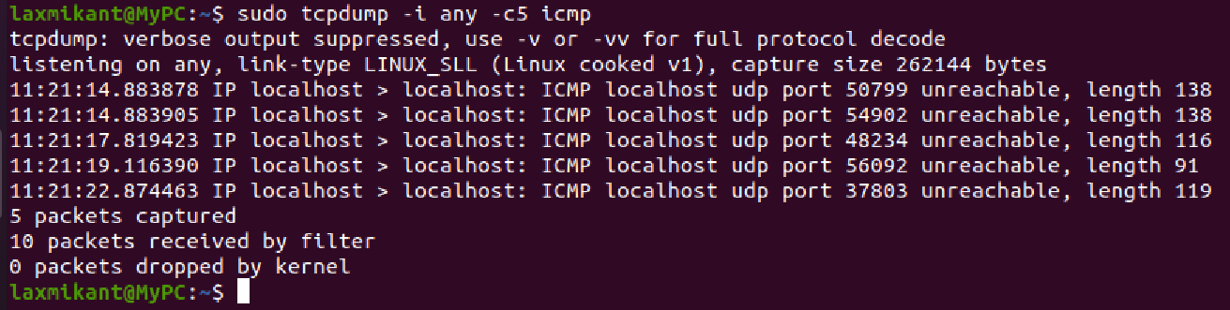

**Step 5:** Check the packet content. For example, inspect the HTTP content of a web request like this:

## sudo tcpdump -i any -c6 -nn -A port 80

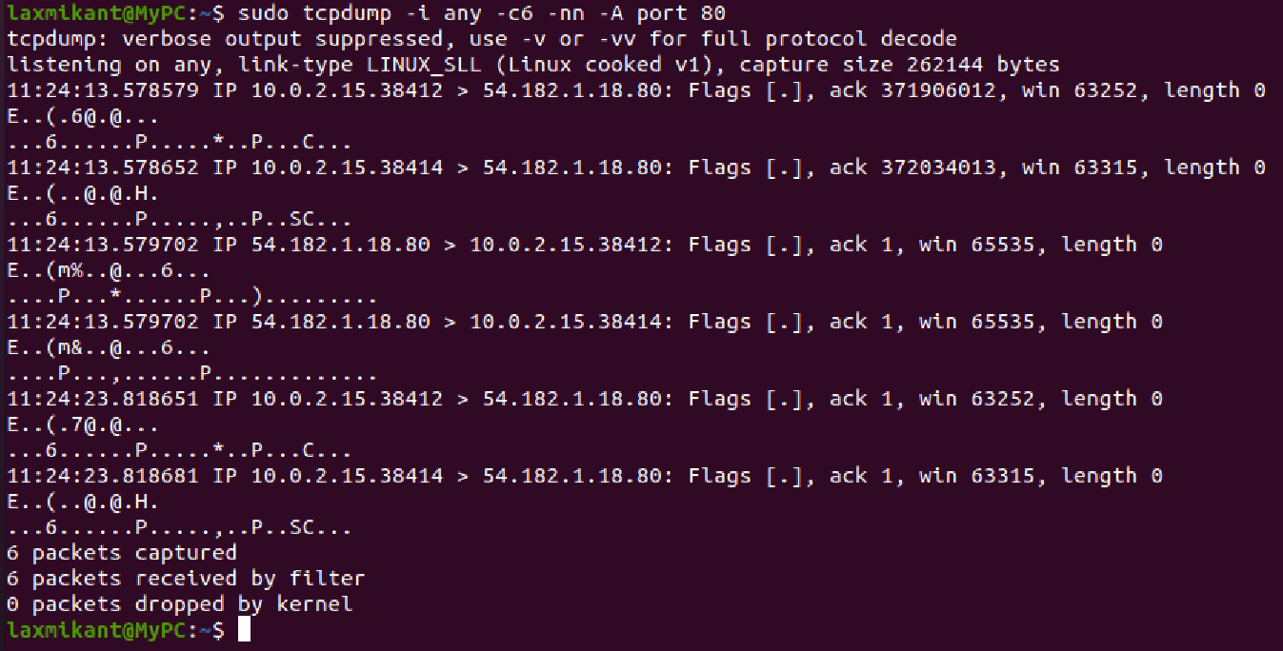

**Step 6:** To save packets to a file instead of displaying them on screen, use the option -w:

**sudo tcpdump -i any -c10 -nn -w webserver.pcap port 80**

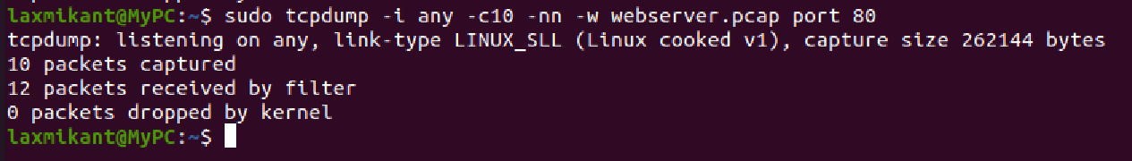

# Task 5: Perform Traceroute checks

**Step 1:** Run the traceroute using the following command.

## sudo traceroute [www.google.com](http://www.google.com/)

**Step 2:** Analyze destination address of google.com and no. of hops

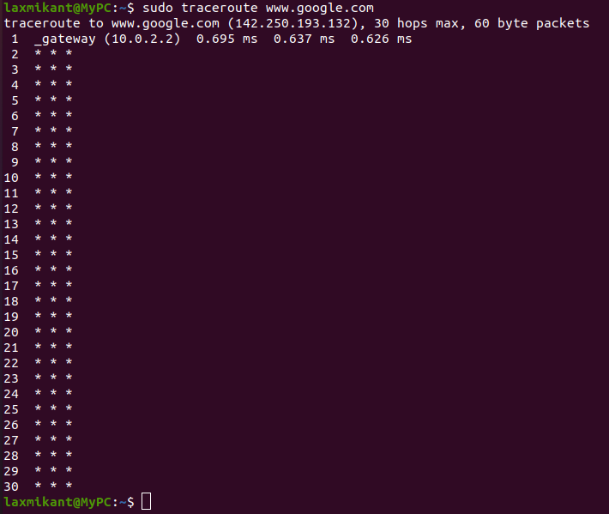

**Traceroute in windows:** tracert [www.google.com](http://www.google.com)

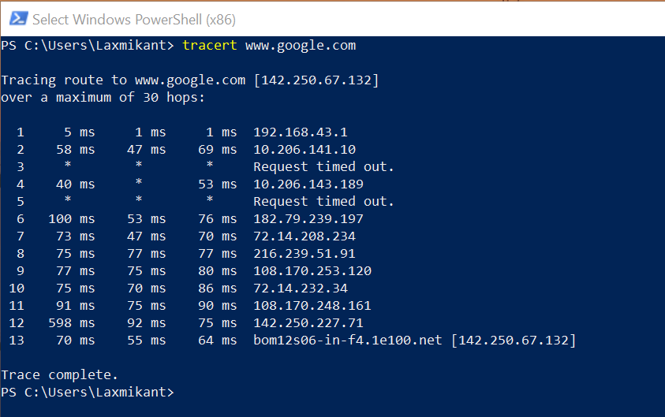

**Step 3:** To speed up the process, you can disable the mapping of IP addresses with hostnames by using the *-n* option

## sudo traceroute -n [www.google.com](http://www.google.com/)

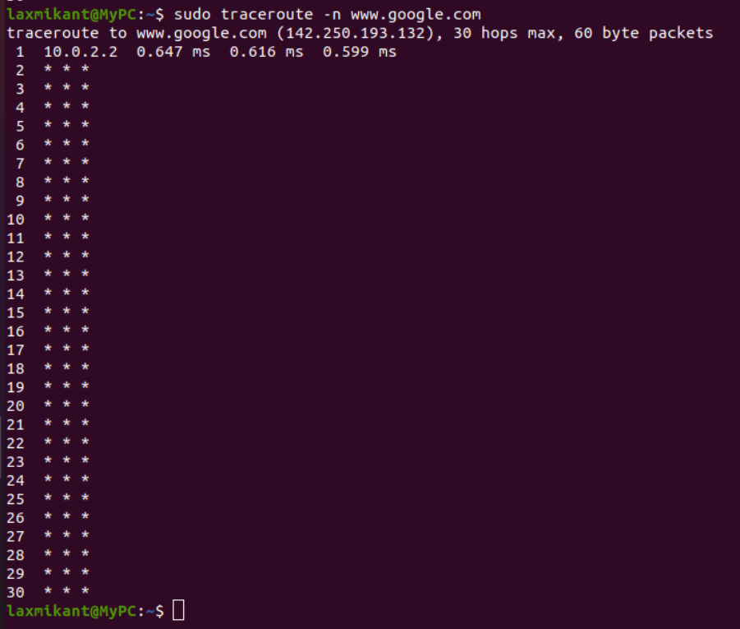

**Step 4:** The -I option is necessary so that the traceroute uses [ICMP.](https://en.wikipedia.org/wiki/Internet_Control_Message_Protocol)

**sudo traceroute -I** [**www.google.com**](http://www.google.com/)

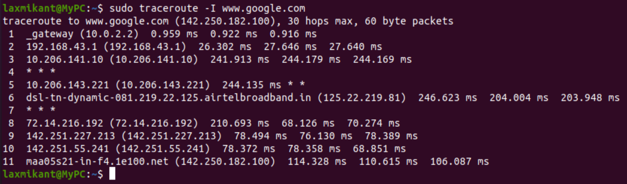

**Step 5:** By default, traceroute uses icmp (ping) packets. If you’d rather test a TCP connection to gather data more relevant to web server, you can use the -T flag.

**sudo traceroute -T** [**www.google.com**](http://www.google.com/)

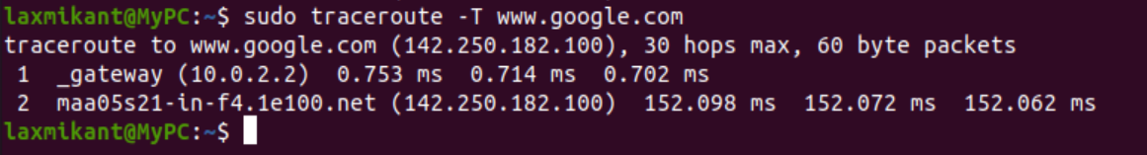

# Task 6: Explore an entire network for information (Nmap)

**Step 1:** You can scan a host using its host name or IP address, for instance.

**nmap www.pesuacademy.com**

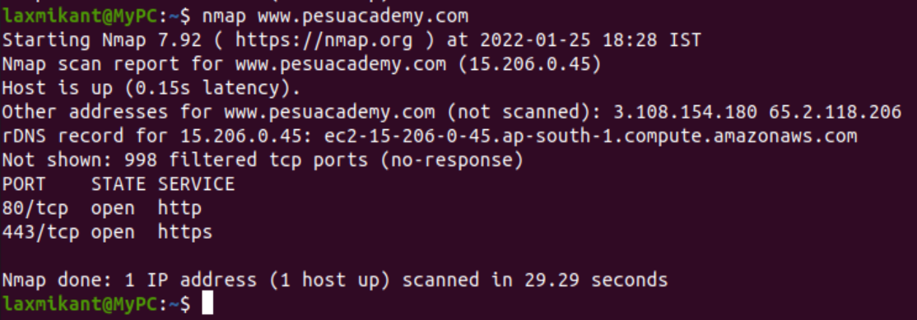

**Step 2:** Alternatively, use an IP address to scan.

## nmap 15.206.0.45

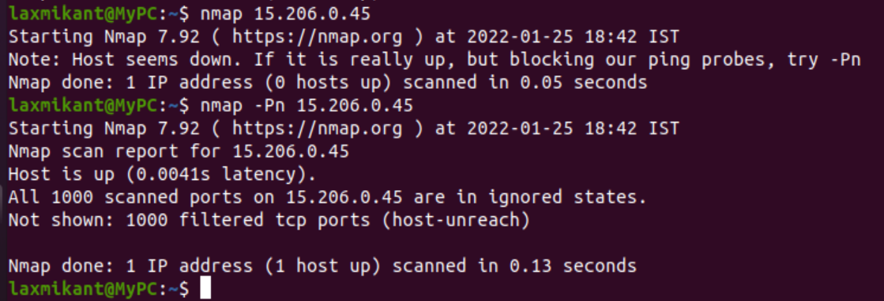

## Step 3: Scan multiple IP address or subnet (IPv4)

## nmap 192.168.1.1 192.168.1.2 192.168.1.3

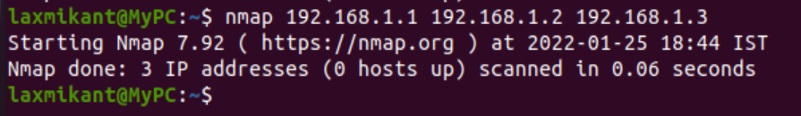

**Questions on above observations:**

1. Is your browser running HTTP version 1.0 or 1.1? What version of HTTP is the server?

ANS:- HTTP version 1.1

The browser is running on HTTP version 1.1 .

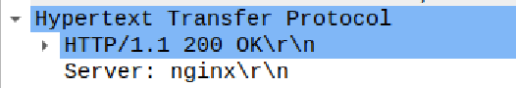

1. When was the HTML file that you are retrieving last modified at the server?

ANS:- The last modified field of the OCSP response gives the last modified time of the HTML file at the server.

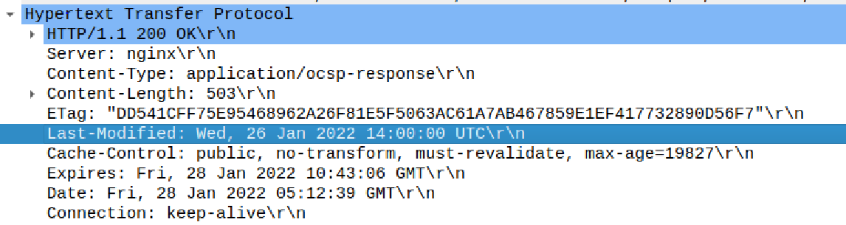

1. How to tell ping to exit after a specified number of ECHO_REQUEST packets?

ANS:- By using the command : ping -c ***no_of_packets IP_address/ URL***

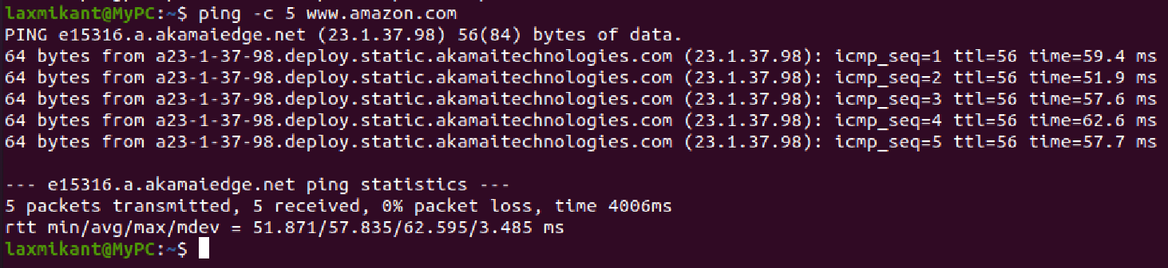

1. How will you identify remote host apps and OS?

**ANS:- Using nmap command:**

nmap -O -v ***IP_address/URL***

This will scan the network and gives the information about host apps and OS.